**NECRO TD**

You are a Necromancer, and all life is sacred to you, especially when you’re using someone else’s life to use as fuel for your unholy abominations. At least they die knowing it was for a worthy cause. Sometimes, the ungrateful masses don’t see it that way however and manage to scrape enough cash together to have some sorcerer, or wizard, or one of the “good” mages to send some sort of creature to get you. Which in turn forces you to create creatures of your own to defend yourself with, which costs life forces, which you take from the nameless and useless plebeians around you, which causes them to get more creatures to get you...it’s all too exhausting really.

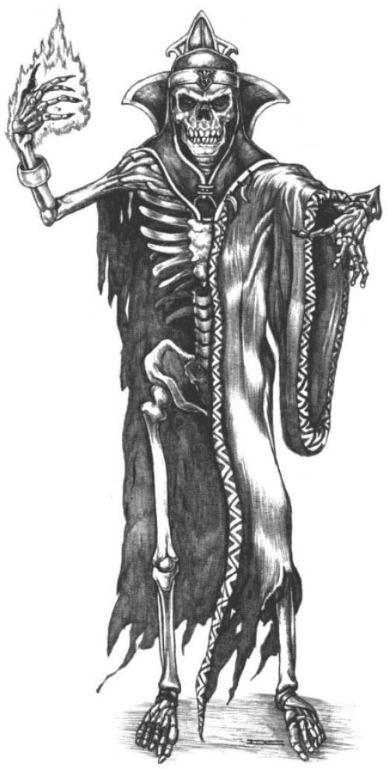

*The stress is killing me, I’m all skin an bo-...oh, no wait, just bones now, thanks peasants.*

Mama Necromancer didn’t raise no dummy Necromancer though, you’ve left enough unholy creature building materials strewn across the countryside to build an entire army of creatures; which you could probably use to rule the region with an iron fist, if you could ever be bothered to get them all in one spot. Where’s the fun in that though? Your walks would be boring otherwise.

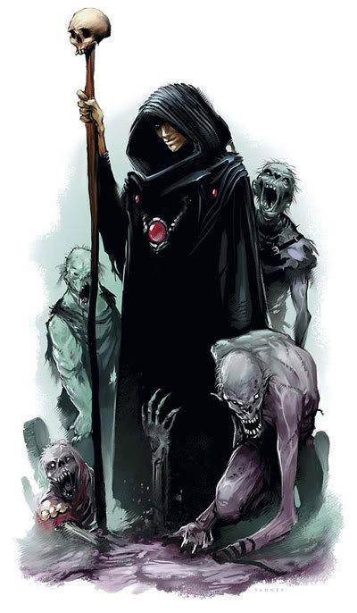

*A kickass walking staff can only do so much, let’s be honest here.*

So far be it from you to end the cycle of perpetual chaos that surrounds you. You’ll walk where you please, and if the peasants send a monstrosity after you, well then you’ll just make the peasants do the only useful thing they’ve ever done with their lives: save yours.

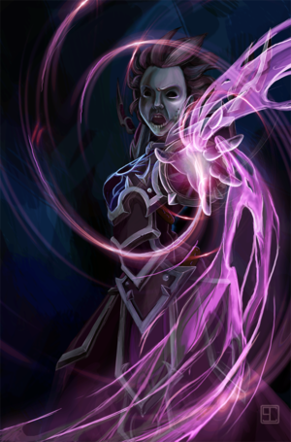

*People I’d like to thank for unwillingly donating their souls to the “Let me Live” fund: Whoever made their soul taste like chocolate. Seriously, how did you do that?*

**Features:**

* **3 Creatures to defend your unholy greatness (Blocking, Slow/Damage over Time, Damage)**
* **Killing monstrous creatures**
* **Spawning mini-creatures**
* **Power-Ups**
* **Flying**
* **Shooting unholy wrath at the creature who dared to try and strike you down.**

**1-Minute Gameplay**

The first minute of gameplay will be pretty basic. You will have a set amount of time before the creature shows up on your screen, during which you will have time to set up your towers. Once the creature appears your towers will begin attack the creature and you will be able to damage the creature directly by clicking on it. The larger creature will spawn numerous smaller ones. Occasionally, you will see a different colored small minion, this will drop a power-up. Once you kill the creature you’ll move on to another. If the creature reaches you, you lose the game. If any of the mini creatures hit you, you lose the game.

**Controls:**

The game will be player with the mouse and keyboard, movement is done with the keyboard and interactions with the mouse (attacking, tower building). The bone piles can be clicked on, which will bring up a radial menu that will show you the towers you can build. You can click on the creature to directly damage it.

**Wireframes:**

Main Menu

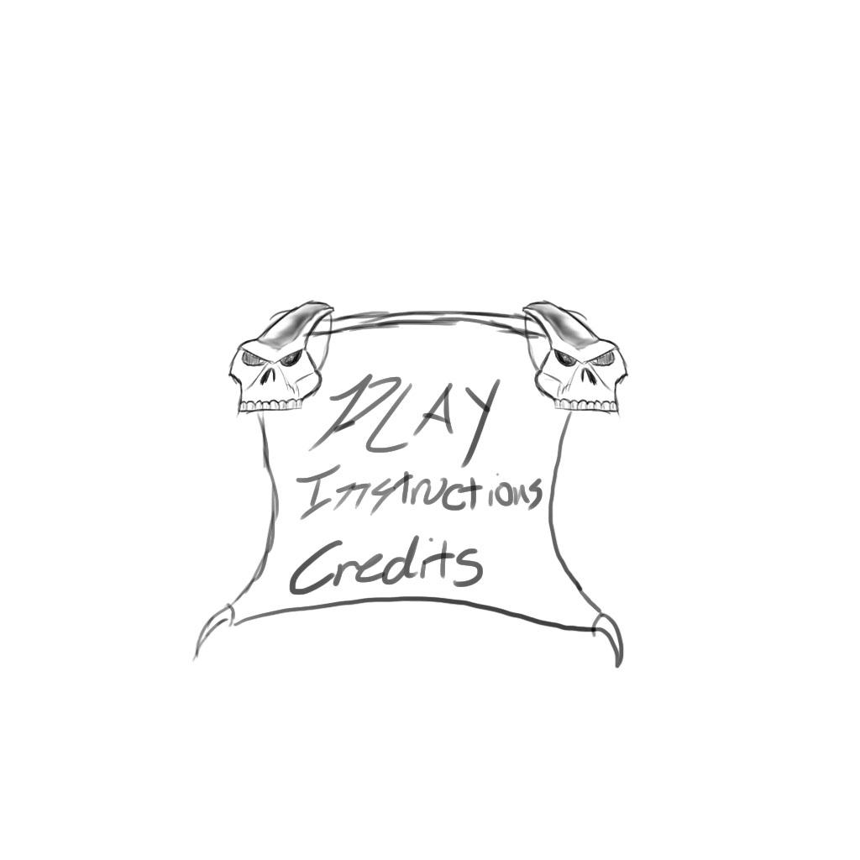

Credits

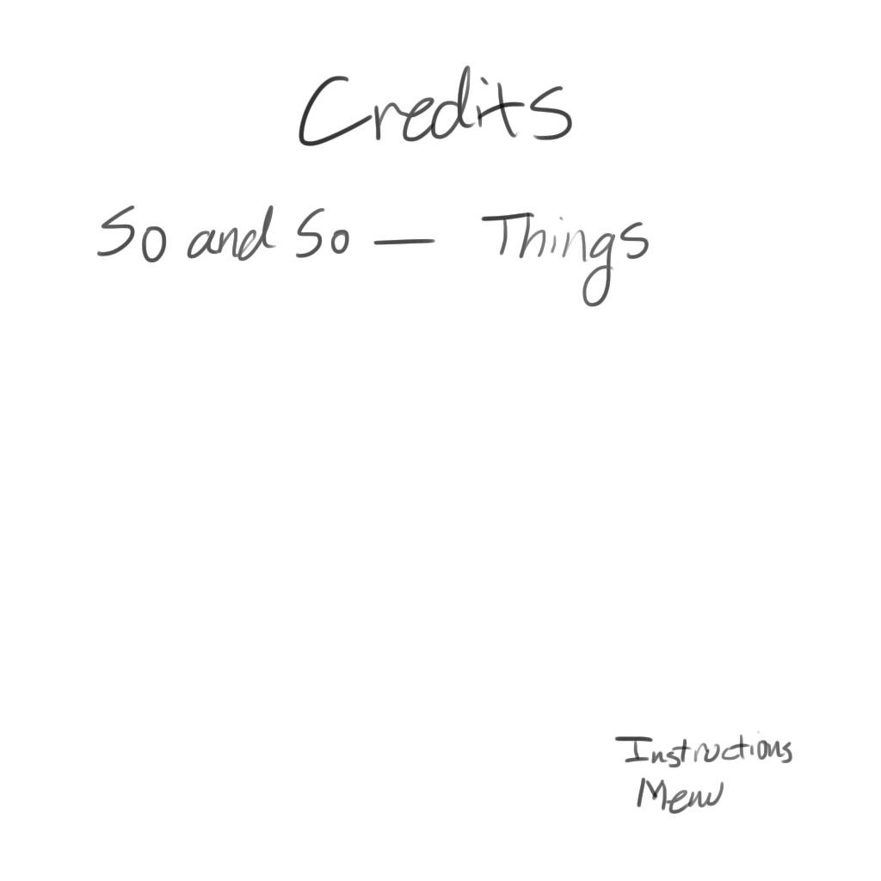

Game Screen/Instructions

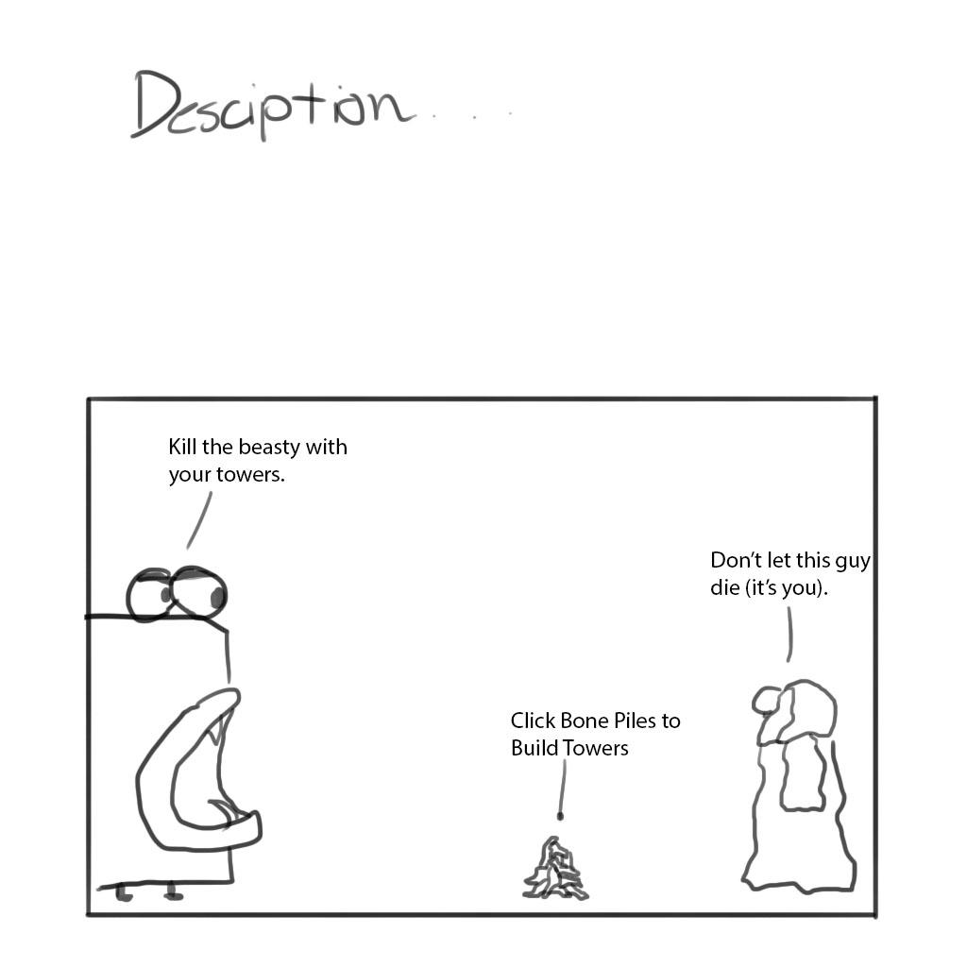

**Flowchart:**

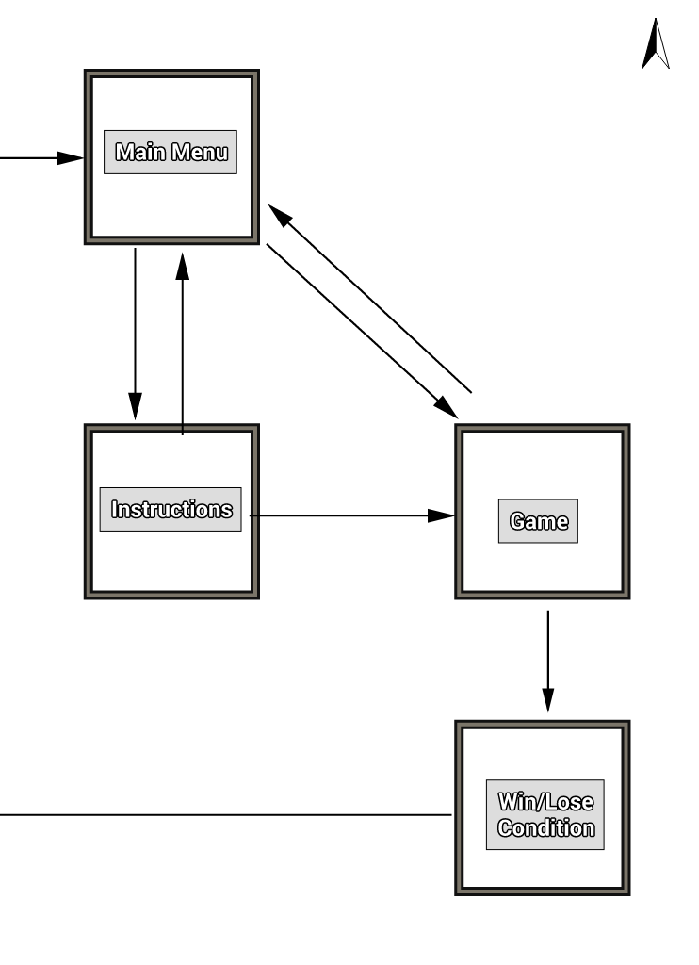

**Tower Types:**

**Damage Tower: Observer, fires a consistent beam at the enemy while it is in range, each pulse deals damage, takes time to charge up and fire however.**

**Tank Tower: Abomination, hulking tower blocks the monster until it (or the monster).**

**Slow Tower: Skeleton Archer, this tower fires poison arrows which slow and damage the target over time.**

**Change Log:**

* Shooting is now fired towards the mouse
* Power-ups spawn an additional tower node
* Enemies spawn from the monster
* Power-ups drop from an extra fast monster
* Boss can pick up power-up, attacks structures faster
* Player now floats instead of jumping
* Menu transitions work
* Slowing tower has a duration on the enemy, no longer permanent.
* Win screen added
* Restart capability added